Sensitivity analysis
For larger cut off
Lose the signinal in Milton
Some from Helene
Ground source: Flashfloods
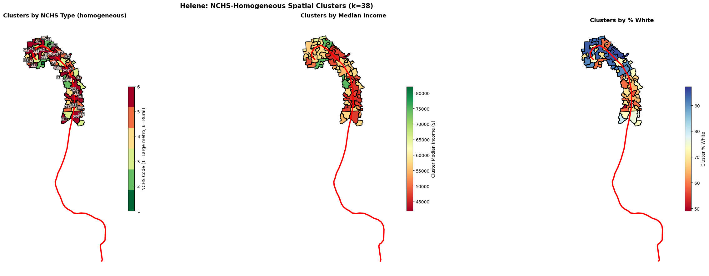

- 4 Figures
- Methods, table
- Introduction is very important
- Story
- Direct effect vs in direct effect
- 格式比较重要
Population weighted flooding data
Modeled wind
Road density
Joint

